TEAM PROJECT REPORT

Synthesis and Characterization of Environmentally Benign Cu/PVA Nanocomposites

Submitted To

The RET Site
For

“Challenge-Based Learning and Engineering Design Process Enhanced Research Experiences for Middle and High School In-Service Teachers”

Sponsored By
The National Science Foundation
Grant ID No.: EEC-1404766

College of Engineering and Applied Science
University of Cincinnati, Cincinnati, Ohio

Prepared By

Kimberly Lykens, Biology Grade 10, Walter E. Stebbins High School, Dayton, Ohio
Todd Hamilton, Science Grade 7-8, Academy of World Languages, Cincinnati, Ohio

Approved By

_________________________________________
Dr. George Sorial
College of Engineering and Applied Science
University of Cincinnati

Reporting Period:

Abstract

Synthesis of nanoparticles is among the fastest growing areas of scientific research due to the unique physicochemical properties attributed by the intermediate nanoscale size (1-100 nm) of the particles between quantum and bulk materials and large surface area-to-volume ratios that enable novel applications. In this study, copper/polyvinyl alcohol (Cu/PVA) nanocomposites were synthesized using chemical reduction method and characterized by various microscopic and spectroscopic analytical techniques. Dynamic light scattering (DLS) technique implied a promising preliminary result on the formation of a stable nanosuspension. UV–Vis absorption spectra showed a UV peak of wavelength of 490 nm with an increase in absorbance intensity as a function of increasing PVA concentration. Transmission electron microscopy (TEM) images revealed the presence of monodispersed and nearly spherical nanoparticles with sizes less than 5 nm. On the other hand, energy dispersive x-ray (EDX), which is attached to TEM, confirmed the presence of strong Cu spectra. The stability analysis of the synthesized nanoparticles under various environmental conditions such as pH, ionic strength, electrolyte valance, and humic acid demonstrated the stability of the particles at pH values at 7 and above. The rate of the catalytic degradation for a methyl blue dye was found to increase with increasing the concentration of Cu/PVA nanoparticles. The stability of the synthesized nanocomposites in various environmental conditions will be a potential advantage for wider applications of catalytic degradation of organic pollutants.

Keywords: Characterize, Copper, nanocomposites, nanoparticles, pollutant, polyvinyl alcohol, synthesis

- INTRODUCTION

Nanoparticles, particles between 1-100 nanometers (nm), are prevalent and unavoidable within the environment in both natural and engineered forms. The existence of natural nanoparticles is evident in air, water, and even within ice core deposits dating back thousands of years (Murr et al., 2004). The application and need for engineered nanoparticles is of growing interest within the scientific community; therefore, nanoparticles are becoming more prevalent within the environment. While there is a strong interest around nanoparticle application from several industries, such as textile, chemicals, electronics, pharmaceuticals, cosmetics, foods, and environmental, there is less of an understanding as to how these particles interact with both aquatic and terrestrial life forms (Guzman et al., 2006; Royal Society, 2004). Ineffective water treatment, debilitating aquatic life, unknown health effects, and decreasing soil microorganisms are all the concerns among the scientific community when considering the use of nanomaterials in agricultural applications.

The application of a particular nanoparticle is dependent on the chemical composition of the particle. Moreover, the physicochemical properties are of particular interest when drawing conclusions about the applications of nanoparticles and their interaction with the environment. Metallic nanoparticles are of particular interest in environmental industries and therefore, the synthesized nanoparticle described within this study is copper (Cu) based. Cu-based nanoparticles have attracted increased attention because of their low cost and abundance availability in contrast to noble metals and the unique catalytic, optical, electrical, electronic, thermal, magnetic, photochemical, biomedical, or antimicrobial properties (Dadgostar, Ferdous & Henneke, 2010; Ghorbani, 2014; Singh, Ojha, & Srivastava, 2009). Furthermore, Cu-based NPs have gotten greater potential in the electronic, chemical, biomedical, energy, agricultural pesticide, and wood preservative industries (Ingle, Duran, & Rai, 2014; Freeman & McIntyre, 2008).

The synthesis of Cu nanoparticles has a big challenge due to inherent/spontaneous tendency to oxidize in ambient conditions, but its low cost compared to other noble metals makes it economically attractive (Magdassi, Grouchko & Kamyshyn, 2010; Niranjan & Chakraborty, 2012). To avoid surface oxidation, an inert environment, such as argon or nitrogen, protective polymers and surfactants, carbon and graphene, and inorganic materials are used (Luechinger, Athanassiou, & Stark, 2008; Athanassiou, Grass, & Stark, 2006).

The purpose of this study is to synthesize and characterize a stable and small size Cu/PVA nanocomposite, analyze how environmental factors influence the physicochemical composition of synthesized nanocomposites, and draw implications about the catalytic application in the degradation of organic contaminants. Furthermore, the application and importance of this study will be elaborated upon and applied within a challenge-based learning (CBL) unit for both high school and middle school students.

- LITERATURE REVIEW

The ubiquitousness of nanoparticles in the world and the opportunity to apply these to various industrial applications is of interest to scientists and engineers worldwide. As the demand for nanoparticles increases as more industries identify uses, understanding how these engineered nanoparticles behave, especially in natural aqueous environments such as waste water, is a top priority (Benn, 2008). The production and engineering of nanoparticles are typically produced using transition metals and metal oxides (Drobne, 2007). Nanoparticle synthesis can be achieved using a top-down or bottom-up approach. Top-down approach uses a litographic technique where in large pieces of metal are milled into smaller particles. Bottom-up approach, due to its convenience and accessibility within the chemical industry, is used more often to synthesize nanoparticles. Bottom-up approach involves chemically synthesizing nanoparticles while paying specific attention to temperature, size, and agglomeration (Borm et al., 2006).

Most nanoparticles in aqueous environments have high ionic strength and tend to cluster. Agglomeration influences the size of nanoparticles and in turn changes the physicochemical properties of the particle such as solubility, color, conductivity, and catalytic behavior (Borm et al., 2006). Metallic nanoparticles are often coated with a polymer compound to maintain a colloidal state during the synthesis process; thus, changing the surface properties of the nanocomposite. In the environmental, a colloidal solution is optimal because it disperses effectively and maintains catalytic behavior (Klaine et al., 2008).

Copper (Cu) in particular is unique in the sense that it can easily participate in redox reactions to create various oxidative states. Copper is a common metal used for studies on nanoparticle synthesis due to copper’s unique properties, the vast amount of alloys it can produce, and the cost effectiveness of the metal in general. Furthermore, the size, shape, and surface properties of copper nanoparticles are easy to control throughout the synthesis process (Hoover, 2006). Previous studies show that copper-based nanoparticles can be toxic to certain aquatic organisms, such as mussels, protozoa, and marine worms (Buffet et al., 2013). While vast amounts of metals can be used in the synthesis of nanoparticles and nanomaterial, understanding how these particles interact with life is critical when considering the expanding implications nanotechnology can play within society.

When synthesizing nanoparticles, it is very important to consider the following variables: i) the precursor metal salt, ii) reducing agent, and iii) stabilizing agent. The stabilizing agent, or capping agent, is used to prevent agglomeration within the synthesized solution (Ramesh et al., 2012). Poly vinyl alcohol (PVA) is often used as a capping agent and combined with copper nanoparticles to create a nanocomposite. PVA is especially valuable due to the non-carcinogenic, non-toxic, water-soluble, and biodegradable characteristics (Patachia, 2003). Some bottom-up chemical methods used to synthesize Cu-based nanocomposites include i) chemical reduction method, ii) microemulsion/colloidal method, iii) sonochemical method, iv) microwave method, v) electrochemical method, and vi) solvothermal decomposition. The simplest and most common of these methods is the chemical reduction method (Song et al., 2004).

Once nanocomposites have been successfully synthesized, characterization of these particles must be conducted in order to learn more about surface properties. Microscopy, specifically transmission electron microscopy (TEM), is a common test used to assess morphology of synthesized nanocomposites. X-ray spectroscopy, scanning electron microscopy, and other advanced microscopy techniques are used to determine nanocomposite morphology (Gawande, 2011). The most common method for determining the abundance of Cu nanoparticles is through atomic absorption spectroscopy. Cu-nanomaterial have unique electron organization and ultraviolet visible spectroscopy (UV-Vis) is a popular method to assess Cu abundance (Tsoncheva, 2013).

- GOALS AND OBJECTIVES

The goal of this study is to synthesize and characterize environmentally benign Cu/PVA nanocomposites. The objectives implemented to achieve this goal include: a) synthesizing Cu/PVA nanocomposites, b) characterizing the nanocomposites, c) assessing the impact of environmental factors (pH, ionic strength, and humic acid) on particle size, and d) investigating the catalytic or photocatalytic activity of the nanocomposites to degrade non-degradable organic pollutants. The listed objectives are completed in an iterative process to achieve quality and accurate results.

- RESEARCH STUDY DETAILS

4.1 Synthesis of Cu/PVA Nanoparticles

There are two general approaches to synthesize nanoparticles: top-down and bottom-up approach. The top-down approach involves reducing bulk materials to smaller particles using various physical techniques. The bottom-up approach includes chemical and biological methods that use atoms, molecules, or clusters to chemically build nanostructures or nanoparticles (Borm et al., 2006). The chemical method was used in this study for synthesizing Cu/PVA nanocomposites due to its economic value, replicability, and ability to control size in laboratory setting.

4.1.1 Materials and Amounts Used

A copper precursor (copper (II) chloride dihydrate (CuCl₂.H₂O)), electrolyte salt (sodium iodide (NaI)), and polyvinyl alcohol (PVA) were used for the synthesis of Cu/PVA nanocomposites. The CuCl₂.H₂O and NaI were chosen as reactants due to their high solubility and PVA was chosen for its stabilizing and compositing properties. Stock solutions of 1M CuCl₂.H₂O, 1M NaI, and 1% (10 g/L) PVA were prepared to make dilutions of CuCl₂.H₂O (0.005M), NaI (0.010M), and PVA (0%, 0.05%, 0.1%, 0.2%, 0.5% and 1%). Other supplies used throughout the synthesis process include a multi-channel peristaltic pump, temperature controlled magnetic stirrers, magnetic bars, Erlenmeyer flask (250 mL), graduated conical-bottom tubes (50 mL), deionized (DI) water, vortex mixer, and analytical balance.

4.1.2 Synthesis Procedures
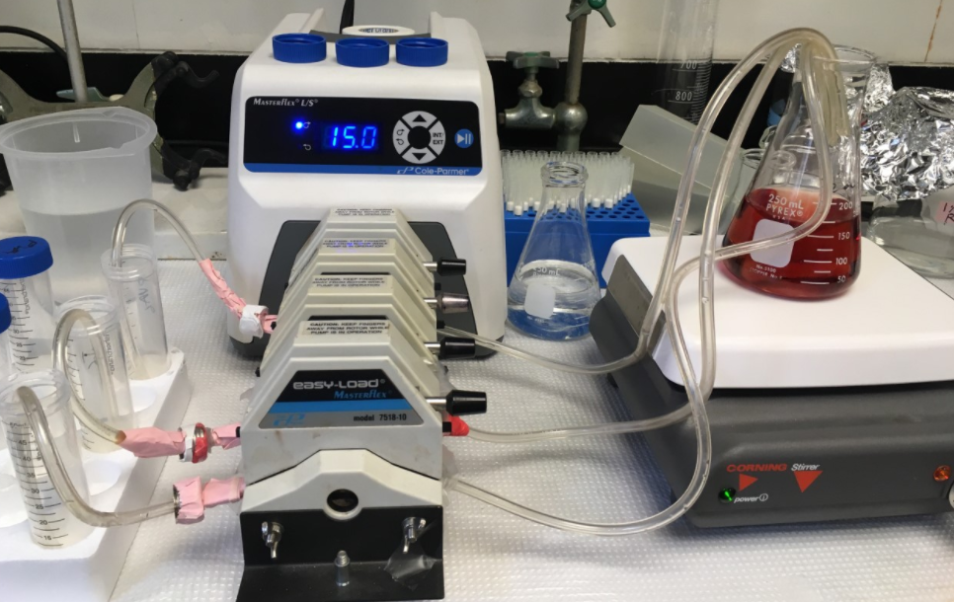
Figure 1. Schematic Diagram for the Synthesis of Cu/PVA Nanocomposites
The stock solutions of 1M CuCl₂.H₂O, 1M NaI, and 1% PVA (left overnight at 80 ºC with gentle stirring to ensure complete dissolution) were prepared prior to synthesis. Dilutions of 0.005M CuCl₂.H₂O, 0.01M NaI, and 0%, 0.05%, 0.1%, 0.2%, 0.5% and 1% PVA were prepared in graduated tubes and sent through peristaltic pump channels at a rate of 15 mL/min. Figure 1 shows the synthesis of Cu nanocomposites. The final solution, which was under vigorous stirring throughout the entire synthesis, was collected in an Erlenmeyer flask and transferred to graduated tubes for nanomaterial characterization.

4.2 Characterization of Cu/PVA Nanoparticles

Selected samples were characterized to collect data on granulometry (size) and morphology (size, shape, and dispersity) using various spectroscopy and microscopy techniques. Characterizing the synthesized nanocomposites gives inference into which samples are best for further testing, analysis, and validate synthesis procedures for optimum output.

4.2.1 Average Particle Size

The hydrodynamic diameter (HDD) of the particles was measured by dynamic light scattering (DLS) (NanoBrook Omni, Brookheaven Instruments Corporation). A sample solution is placed in a cuvette and the cuvette is placed in the DLS sample holder where light will pass through the solution measuring the intensity and size of the nanoparticles. The HDD of triplicate samples was gathered to study sample consistency and accuracy (Appendix III; 1).

4.2.2 Spectroscopy

Spectroscopy techniques such as ultraviolet visible (UV-Vis) spectroscopy (Agilent Technologies, Cary 8454) and atomic absorption (AA) spectroscopy (Perkin Elmer, AAnalyst 300) were used to measure the wavelength/absorbance and concentration of the synthesized nanoparticles, respectively. The UV-Vis spectrophotometer measures wavelength and absorbance intensity of particles present in a sample (Appendix III; 2). All materials have reflective property that can be used to identify the material using the visible light spectrum. The AA spectrophotometer measures elemental composition of Cu of the synthesized nanocomposites (Appendix III; 3).

4.2.3 Microscopy

The morphology of the Cu/PVA nanocomposites was determined using a transmission electron microscope (TEM) (CM-20 operating at 200 kV) (Appendix III; 4). Selected Cu/PVA nanocomposites were prepared on TEM gold grids and dried to be examined for TEM imaging ranging from 100,000-580,000 times magnification. TEM transmits a beam of electrons through a sample to allow the observer to explore materials of nanometer size with high resolution. The TEM images were examined for size, shape, and dispersity.

4.2.4 Electron Dispersive X-Ray Spectroscopy

Electron dispersive X-ray (EDX) spectroscope was used to identify and quantify elemental compositions present within the Cu/PVA nanoparticle sample analyzed by TEM. EDX uses x-rays to excite the atomic structure of each element in the sample. Due to each element having a unique atomic structure, each element will give off a different amount of energy that will be quantified using the EDX.

4.3 Impact of Environmental Factors on HDD

The as prepared nanocomposites were investigated in various environmental conditions such as pH, ionic strength, and humic acids. The nanocomposite samples were adjusted to six different ionic strengths [(0.001M, 0.01M, and 0.1M NaCl) and (0.001M, 0.01M, and 0.1M CaCl₂)]. The pH was also adjusted to 5, 7, and 9 using a 0.1M HCl or NaOH solution and humic acid was introduced with 0, 5, and 20 mg/L concentrations. The HDD of the particles were measured for each environmental condition by DLS after each suspension was adjusted to the target ionic strength, pH, and humic acid concentrations and stirred for nearly 15 minutes.

4.4 Degradation of Methylene Blue

A degradation of organic contaminants experiment under solar light was conducted to find out if the synthesized Cu/PVA nanocomposites have catalytic or photocatalytic potential. Methylene blue is considered as a model of organic contaminant. To accomplish this, a buffer solution of 1L of 0.05 M KH₂PO₄ was prepared and adjusted to pH 7 using 0.1 M NaOH, and a stock solution of methylene blue (MB) dye (500 mL of 250x10⁻⁶ M) was prepared using the buffer solution. A 10, 20, 30, 40, and 50 µM MB standards were prepared from the stock solution to calibrate the UV-Vis spectrophotometer at a UV wavelength of 664 nm. A 50 mL of 50 µM MB solution and Cu/PVA nanocomposite ((62.5, 125, 250, and 500 mg/L with 0 % PVA), (250 and 500 mg/L with 0.1% PVA), and (500 mg/L with 0.5% PVA), one at a time) were prepared in three separate petri dishes (photocatalytic reactors) and placed in different light exposures: dark, room light, and UV light (300 watt), respectively. The three petri dishes were exposed to their corresponding environments for a total of 120 minutes. Each sample was analyzed at 0, 30, 60, and 120 minutes for methylene blue degradation using UV-Vis spectrophotometer after 2 mL of each sample was taken and filtered with 0.45-micron syringe filter.

- RESEARCH RESULTS

5.1 Synthesis

The synthesized Cu-nanocomposites varied in color and amount of visible agglomeration based on (i) the amount of poly vinyl alcohol (PVA), (ii) the reducing agent, and (iii) the concentration of the chemical reactants. Figure 2 shows the difference in homogeneity and color that took place from 0% PVA to 0.5% PVA within the Cu/PVA nanocomposites. A red/yellow coloration was observed in CuI₂ (copper (II) iodide) and the intensity of color increased in every sample with the increase of PVA within the sample.

5.2 Characterization

5.2.1 Average Particle Size

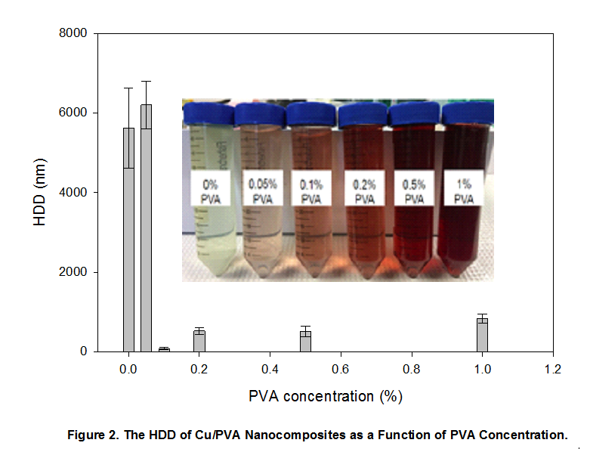
Average particle size was measured for Cu/PVA nanocomposites using PVA concentrations of 0%, 0.05%, 0.1%, 0.2%, 0.5%, and 1%. The results were obtained using DLS technique which measures particles HDD in nanometers (nm). Figure 2 shows PVA concentrations and particle size in nm for each sample. It was found that particle size is the lowest when 0.1% PVA is used for copper nanoparticle synthesis. There was no significant difference between 0.2% and 0.5% PVA. However, nanoparticle size increased when a larger concentration of 1% PVA was added. 0% and 0.05% PVA concentrations yielded the largest sizes on average and the largest standard deviation. This suggests that lower concentrations of PVA within the synthesis give larger particle sizes and more inconsistency in the particle size. Also, samples synthesized with 0% and 0.05% PVA showed particle sizes outside of the nanoparticle range of 0-100 nm. PVA concentrations of 0.1%, 0.2%, and 0.5% were further used for synthesis and environmental testing because particles fell within the nanoparticle range of 0-100 nm. Low standard deviation within the samples of 0.1%, 0.2%, and 0.5% PVA also show that the nanoparticles have consistent sizes.

5.2.2 UV-Vis Spectroscopy

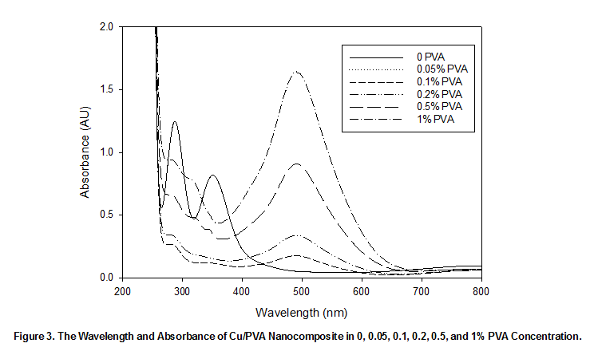
CuI/PVA samples were tested for particle wavelength (nm) and absorbance (AU) using UV-Visible (UV-Vis) spectroscopy. Each sample contained 0.005M of copper chloride (CuCl2), 0.01M of sodium iodide (NaI), and PVA concentrations of 0%, 0.05%, 0.1%, 0.2%, 0.5%, and 1%. Figure 3 shows the particle wavelength (nm) and absorbance (AU) for each sample. Absorbance will measure the abundance of particles within each sample. Wavelength will identify if any reactions have occurred that would cause alteration to the particles characteristics. UV–Vis absorption spectra showed a UV peak wavelength of 490 nm with an increase in absorbance intensity as a function of increasing PVA concentration (Fig. 3).
Figure 3. The Wavelength and Absorbance of Cu/PVA Nanocomposite in 0, 0.05, 0.1, 0.2, 0.5, and 1% PVA Concentration.

5.2.3 Atomic Absorption Spectroscopy

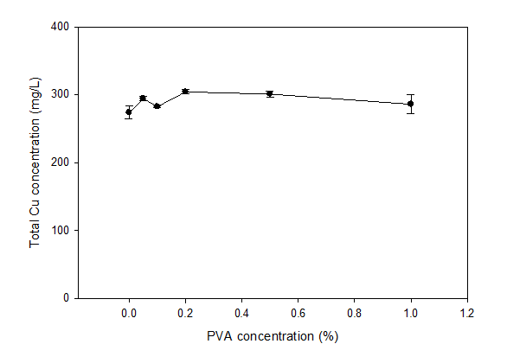
Atomic absorption spectroscopy results showed a presence of Cu in all PVA concentrations regardless of the percentage of polymer (PVA). The results show (Fig. 4) that the concentration of Cu/PVA nanocomposite samples had non-significant difference with the increase of PVA content. The results also suggest that the synthesized nanoparticles are extremely small (2-3 nm) and pass through the 10 kDa ultrafiltration tube during centrifugation process.
Figure 4. Total concentration of Cu as a Function of PVA percentage After 10 kDa Ultrafiltration

5.2.4 TEM

Samples of the synthesized Cu/PVA nanocomposites were analyzed using TEM. The TEM image shows the morphology of the nanoparticles (nearly spherical particles with sizes less than 5 nm) and the presence of PVA within each sample. Figure 5 shows the morphology of Cu/PVA nanoparticles with 0.1%, 0.2%, and 0.5% PVA concentrations. Increasing the concentration of PVA made it difficult to identify the nanoparticles morphology. The 0.5% concentration of PVA blocks the imaging of the nanoparticles resulting in less clarity of the image.

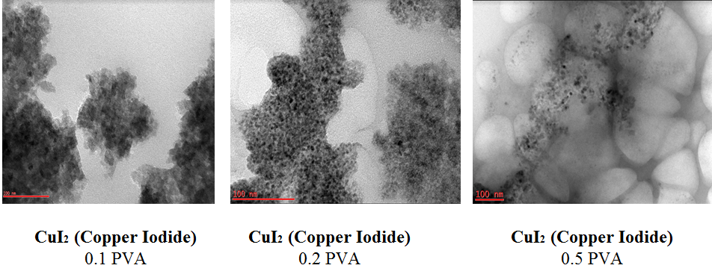
Figure 5. TEM Images of Cu/PVA Nanocomposites with Increasing PVA Concentration

0.1% PVA
0.2% PVA
0.5% PVA

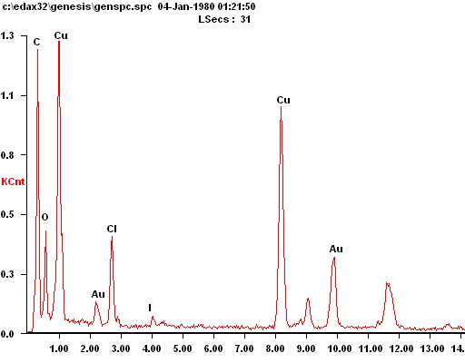
5.2.5 EDX
Figure 6. Cu Abundance in Cu/PVA Nanocomposite with 1% PVA Concentration using EDX

Samples of Cu/PVA nanocomposites with 0.1% PVA were tested using energy dispersive X-ray (EDX) attached to TEM spectroscopy. The result in Fig. 6 confirms the presence of strong Cu spectra. The presence of gold (Au) spectrum is from the TEM gold grid, whereas iodide and chloride from the Cu precursor and electrolyte salt, respectively. The strong spectrum of carbon is from the gold grid coated with carbon and from the PVA polymer, whereas the oxygen spectrum is from the PVA polymer.

5.3 Impact of Environmental Factors on Particle Size

Environmental conditions such as pH, ionic strength, electrolyte valance, and humic acid at different values were analyzed in order to identify how they influence the size of Cu/PVA nanoparticles. Figure 7 shows that the more acidic environments correlate with aggregation and instability of the particles with more variance. Increasing pH (neutral and basic) proportionally creates more stable Cu/PVA nanoparticles in terms of particle size distribution. The results show that increasing ionic strength and humic acid concentration does not significantly influence particle size and variance. Furthermore, there is no significant size difference between monovalent (NaCl) and divalent (CaCl₂) electrolyte valance at all pH, ionic strength, and humic acid values.
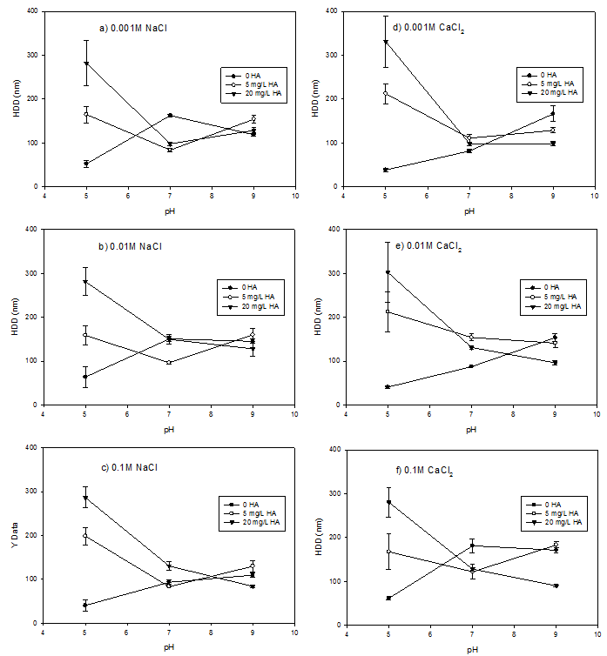
5.4 Degradation of Methylene Blue
Figure 7. Particle HDD as a Function of pH, Ionic Strength, and Electrolyte Balance for Cu/PVA Nanocomposites in 0, 5, and 20 mg/L Humic Acid Suspensions

Solar degradation results show that as the Cu concentration of a sample increases, the degradation rate of methylene blue, a common pollutant, increases proportionally regardless of PVA concentration. Figure 8 shows that Cu concentrations of 500 mg/L degraded almost all methylene blue, while lower concentrations such as 62.5 mg/L, 125 mg/L, and 250 mg/L degraded 20%, 40%, and 60% of the methylene blue, respectively. There is no significant difference in percent degradation between the varying environments (UV light, room light, and dark) and the rate of degradation does not change significantly over time.

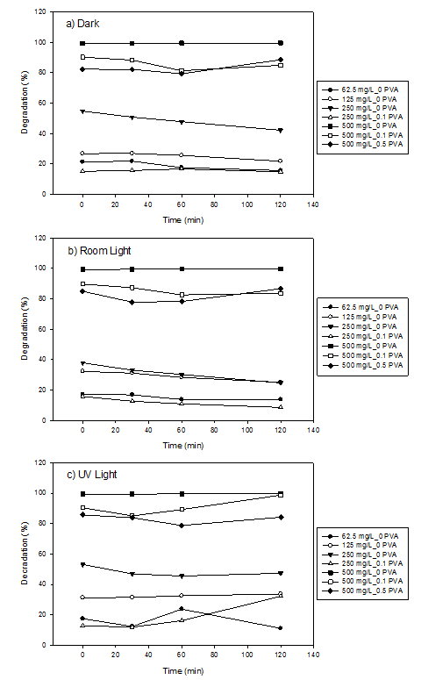
Figure 8. Degradation of Methylene Blue Dye using Cu/PVA Nanocomposite Under a) Dark, b) Room, c) UV Light Conditions

- CONCLUSIONS

The goal of synthesizing environmentally benign Cu/PVA nanocomposites was successful in terms of creating small and stable nanoparticles. The solutions derived from the synthesis process showed various colors depending on the PVA concentration and were consistently stable with the presence of PVA. The UV-Vis spectroscopy characterization shows that the synthesized Cu/PVA nanocomposite absorbance intensity is dependent on the concentration of PVA; thus, indicating a possible catalytic property or stabilizing potential from the PVA polymer. The TEM results provided insight into the morphology of the nanoparticles and showed how PVA negatively influences image clarity. The EDX provided a confirmation that Cu was present in the Cu-based nanoparticles. Furthermore, it is shown that the largest environmental influence on particle size is pH, wherein acidic environments there may be more agglomeration and in neutral/basic environments more stability may be present among nanoparticles. The implications of these findings show that a fairly stable, thus environmentally benign, nanocomposite was synthesized that performs well in environmental applications. Lastly, the Cu/PVA nanocomposite potential to degrade organic pollutants in high Cu concentrations may confirm a catalytic potential. These nanocomposites are not photocatalytic; however, they have the potential to catalyze non-degradable organic pollutants regardless of light intensity.

- RECOMMENDATIONS

Recommendations for future research include using X-ray diffraction (XRD) methods to further validate and identify the type of nanomaterial present in the synthesized solution. Other recommendations include testing other factors, such as time and temperature, that may influence stability of nanoparticles. The catalytic potential of the synthesized nanoparticles to degrade other non-degradable organic pollutants besides methylene blue is also suggested for further research. While the complete degradation of methylene blue was achieved, the decolorization of this organic pollutant should be a large focus in further study. The toxicity of these nanoparticles should also be assessed to further contribute an understanding of their environmental risk.

- ACKNOWLEDGEMENTS

The authors of this paper would like to acknowledge and thank the National Science Foundation for their financial support throughout this study. They would also like to acknowledge the guidance provided by faculty mentors, Dr. George Sorial and Dr. Margaret Kupferle, and their Graduate Research Assistant, Ayenachew Tegenaw. Gratitude would also like to be extended to RET Project Director and Principal Investigator, Dr. Anant R. Kukreti, and RET Resource Person & Grant Coordinator, Debbie Liberi. The RET Program is funded by Grant ID # EEC-1404766: “Challenge-Based Learning and Engineering Design Process Enhanced Research Experiences for Middle and High School In-Service Teachers.” Any opinions, findings, and conclusions or recommendations expressed in this material are those of the authors and do not necessarily reflect the views of the National Science Foundation.

- BIBLIOGRAPHY
Athanassiou, E. K.; Grass, R. N.; Stark, W. J. (2006). Large-scale production of carbon-coated copper nanoparticles for sensor applications. Nanotechnology, 17, 1668-1673.

Benn, T. & Westerhoff, P. (2008). Nanoparticle silver released into water from commercially available sock fabric. Environ. Sci. Technol. 2008, 42, 4133–413910.1021/es7032718.

Borm, P., Robbins, D., Haubold, S., Kuhlbusch, T., Fissan, H., Donaldson, K., Schins, R., Stone, V., Kreyling, W., Lademann, J., Krutmann, J., Warheit, D., Oberdorster, E., 2006. The potential risks of nanoparticles: a review carried out for ECETOC. Particle Fibre Toxicol. 3, 11.
Buffet, P. E.; Richard, M.; Caupos, F.; Vergnoux, A.; PerreinEttajani, H.; Luna-Acosta, A.; Akcha, F.; Amiard, J. C.; Amiard-Triquet, C.; Guibbolini, M.; Risso-De Faverney, C.; Thomas-Guyon, H.; Reip, P.;
Dadgostar, N. Ferdous, S.; Henneke, D. (2010). Colloidal synthesis of copper nanoparticles in a two-phase liquid-liquid system. Mat. Lett. 64, 45-48.

Drobne D. 2007. Nanotoxicology for safe and sustainable nanotechnology. Arh Hig Rada Toksikol 58:471–478.
Dybowska, A.; Berhanu, D.; Valsami-Jones, E.; Mouneyrac, C. A Mesocosm Study of Fate and Effects of CuO Nanoparticles on Endobenthic Species (Scrobicularia plana, Hediste diversicolor). Environ. Sci. Technol. 2013, 47 (3), 1620−1628.
Freeman, M. H.; McIntyre, C. R. (2008). A comprehensive review of copper-based wood preservatives with a focus on new micronized or dispersed copper systems. Forest Prod. J. 58, 6-27.

Gawande, M. B.; Branco, P. S.; Parghi, K.; Shrikhande, J. J.; Pandey, R. K.; Ghumman, C. A. A.; Bundaleski, N.; Teodoro, O.; Jayaram, R. V. Synthesis and Characterization of Versatile MgO-ZrO2 Mixed Metal Oxide Nanoparticles and Their Applications. Catal. Sci. Technol. 2011, 1, 1653−1664.
Ghorbani, H. R. (2014). Chemical synthesis of copper nanoparticles. Orien. J. Chem. 30, 803-806.

Guzman, K.A.D, Finnegan, M.P., and Banfield, J.F. (2006). “Influence of surface potential on aggregation and transport of titania nanoparticles. Environmental Science Technology, 40, 7688-7693.
Ingle, A. P.; Duran, N.; Rai, M. (2014). Bioactivity, mechanism of action, and cytotoxicity of copper-based nanoparticles: a review. Appl. Microbio. Biotechnol. 98, 1001-1009.

Klaine, S. J.; Alvarez, P. J. J.; Batley, G. E.; Fernandes, T. F.; Handy, R. D.; Lyon, D. Y.; Mahendra, S.; McLaughlin, M. J.; Lead, J. R. Environ. Toxicol. Chem. 2008, 27, 1825−1851.

Luechinger, N. A.; Athanassiou, E. K.; Stark, W. J. (2008). Graphene-stabilized copper nanoparticles as an air-stable substitute for silver and gold in low-cost ink-jet printable electronics. Nanotechnology, 19, 445201.

Magdassi, S.; Grouchko, M.; Kamyshyn, A. (2010). Copper nanoparticles for printed electronics: routes towards achieving oxidation stability. Materials 3, 4626-4638.

Murr, L.E., Esquivel, E.V., Bang, J.J., de la Rosa, G., and Gardea-Torresdey, J.L. (2004). Chemistry and nanoparticle compositions of a 10 000 year-old ice core melt water. Water Resources, 38, 4282-4296.
Niranjan, M. K.; Chakraborty, J. (2012). Synthesis of oxidation resistant copper nanoparticles in aqueous phase and efficient phase transfer of particles using alkanethiol. Colloids and Surfaces A: Physicochem. Eng. Aspects 407, 58-63.

Patachia S. (2003). Blends based on poly (vinyl alcohol) and the products based on this polymer. In Handbook of Polymer Blends and Composites, Vasile C., Kulshreshtha A.K. (Eds.), RAPRA Technology Ltd, Shrewsbury, UK, 285-364.
Ramesh, C., Hariprasad, M., Ragunathan, V., and Jayakumar, N. (2012). “A novel route for synthesis and characterization of green Cu2O/PVA nano composites.” European Journal of Applied Engineering and Scientific Research, 1(4), 201-206.

Royal Society, 2004. Nanoscience and nanotechnologies: opportunities and uncertainties. Report by the Royal Society and the Royal Academy of Engineering.

Singh, D. P.; Ojha, A. K.; Srivastava, O. N. (2009). Synthesis of different Cu(OH)₂ and CuO (nanowires, rectangles, seed-, belt-, and sheetlike) nanostructures by simple wet chemical route. J. Phys. Chem. C, 113, 3409-3418.

Song, X.; Sun, S.; Zhang, W.; Yin, Z. A Method for the Synthesis of Spherical Copper Nanoparticles in the Organic Phase. J. Colloid Interface Sci. 2004, 273, 463−469.

Tsoncheva, T.; Gallo, A.; Spassova, I.; Dimitrov, M.; Genova, I.; Marelli, M.; Khristova, M.; Atanasova, G.; Kovacheva, D.; Dal Santo, V. Tailored Copper Nanoparticles in Ordered Mesoporous KIT-6 Silica: Preparation and Application as Catalysts in Integrated System for NO Removal with Products of Methanol Decomposition. Appl. Catal., A 2013, 464-465, 243−252.

- APPENDIX I: NOMENCLATURE USED
µM = micro molar
AAS= Atomic Absorption Spectroscopy
AU= Absorbance Unit
DLS= Dynamic Light Scattering
EDX= Electron Dispersive X-Ray
HDD= Hydrodynamic diameter
kDa= Kilodalton
L= Liter
M= Molar
mL = milliliter
nm= Nanometers
PVA= Polyvinyl Alcohol
TEM= Transmission Electron Microscopy
UV-Vis= Ultraviolet Visible

- APPENDIX II: RESEARCH SCHEDULE

Week 1 Research Schedule
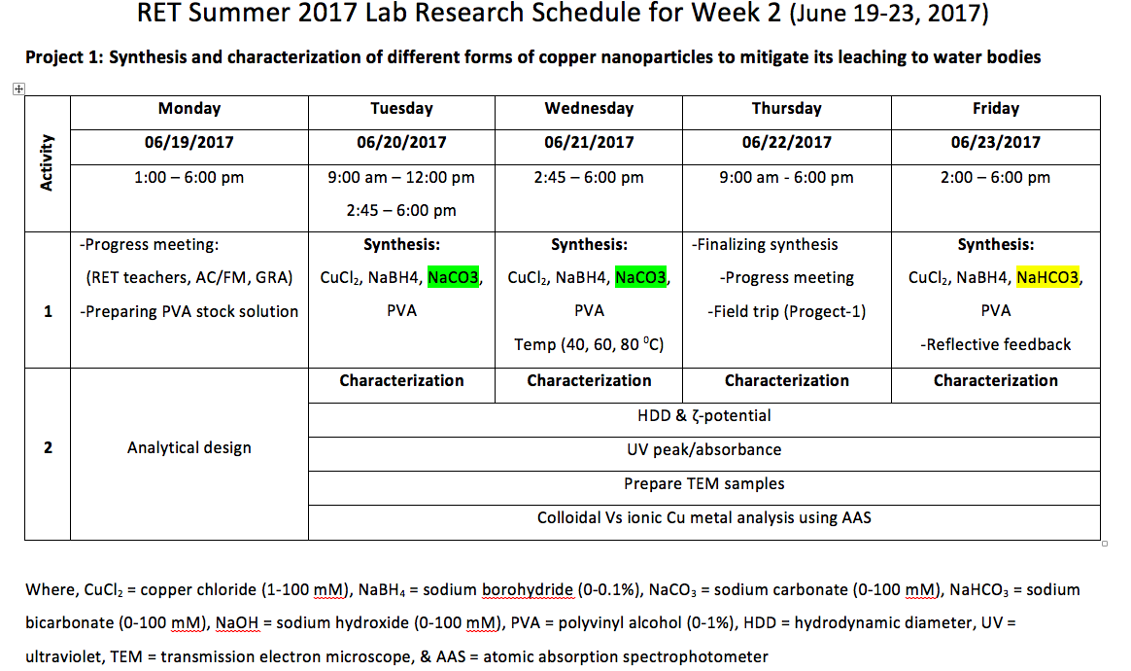

Week 2 Research Schedule
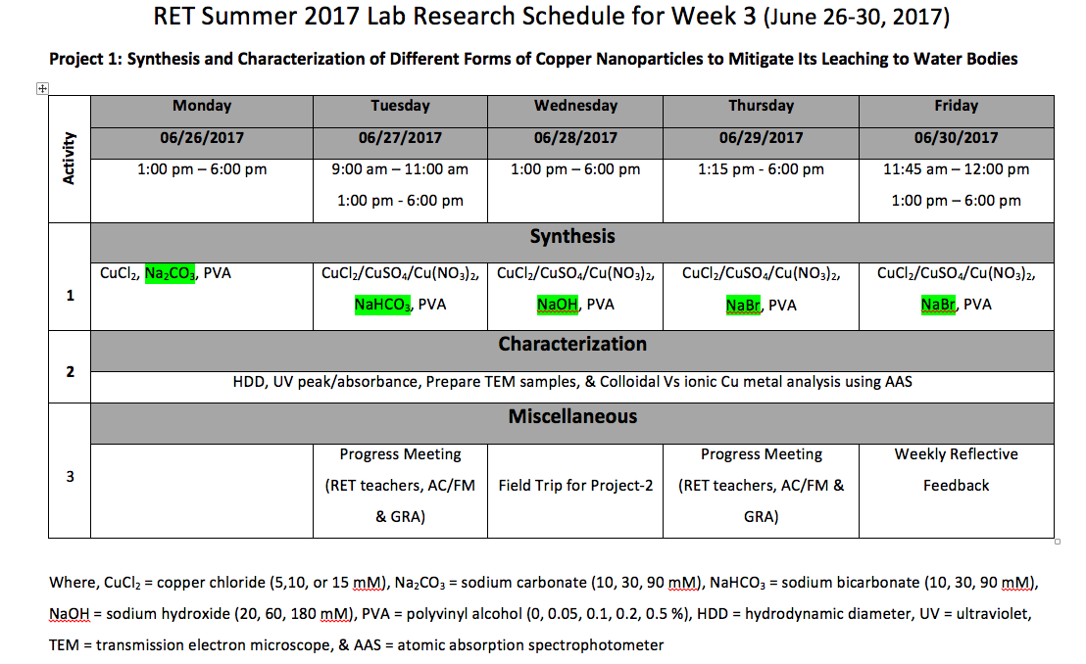

Week 3 Research Schedule
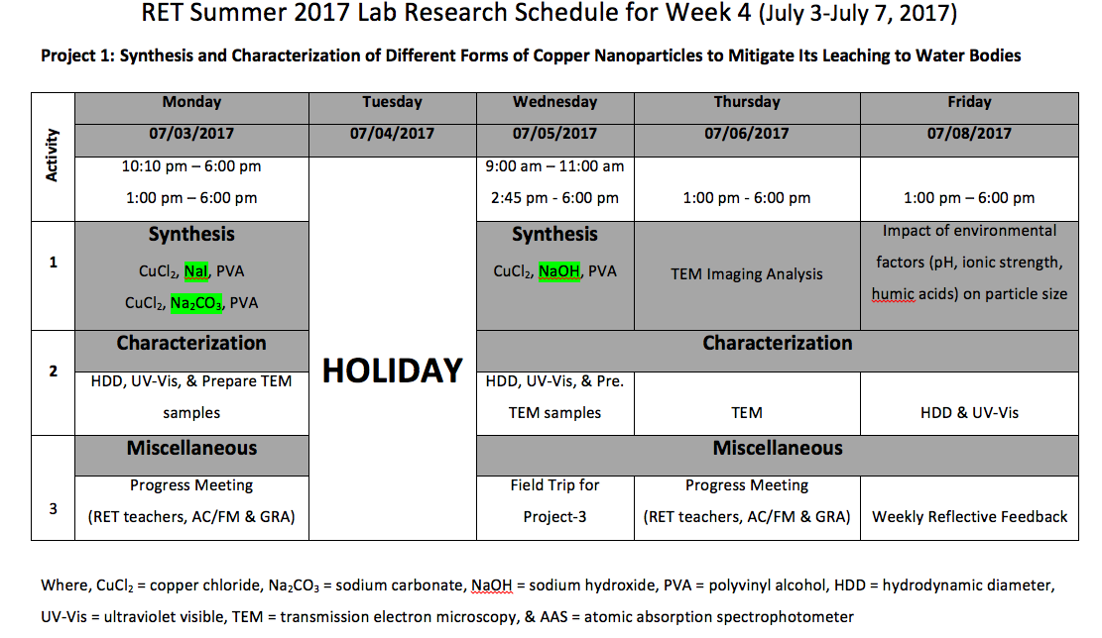

Week 4 Research Schedule
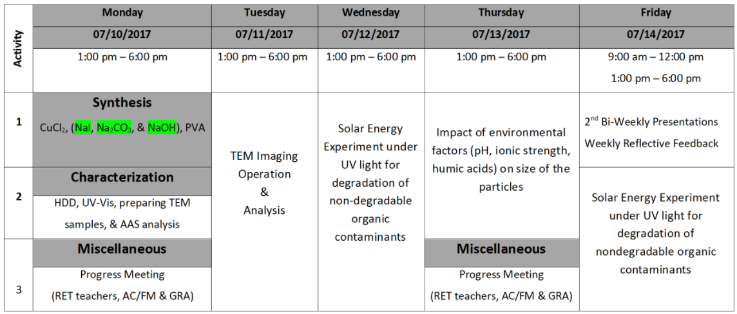

Week 5 Research Schedule
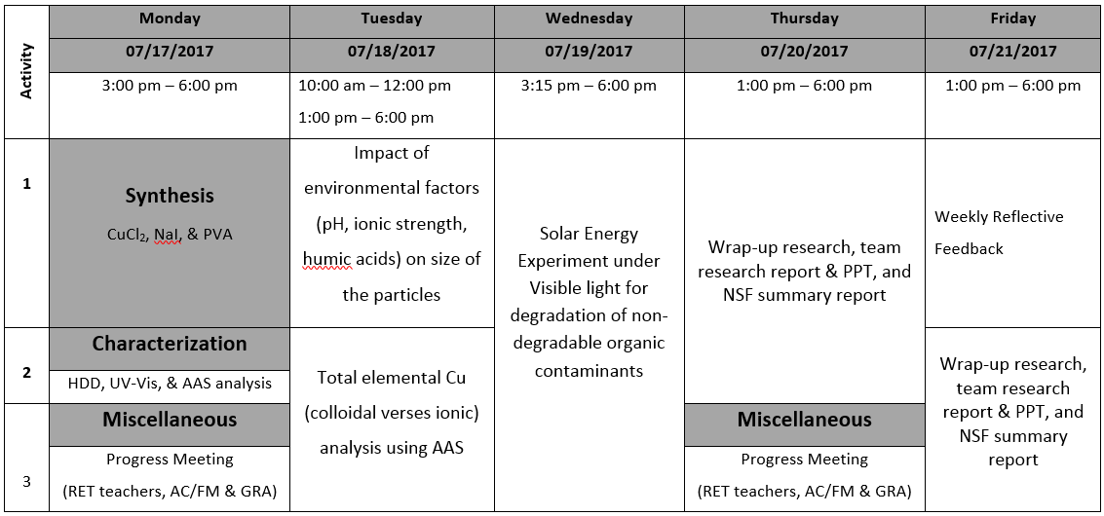

- APPENDIX III: EQUIPTMENT USED

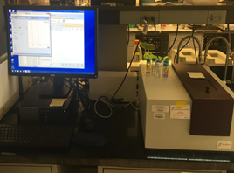

- Hydrodynamic Diameter Machine Used for Size Characterization

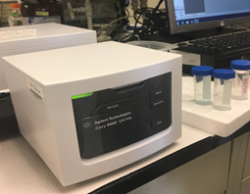

- UV-Vis Spectroscopy Machine

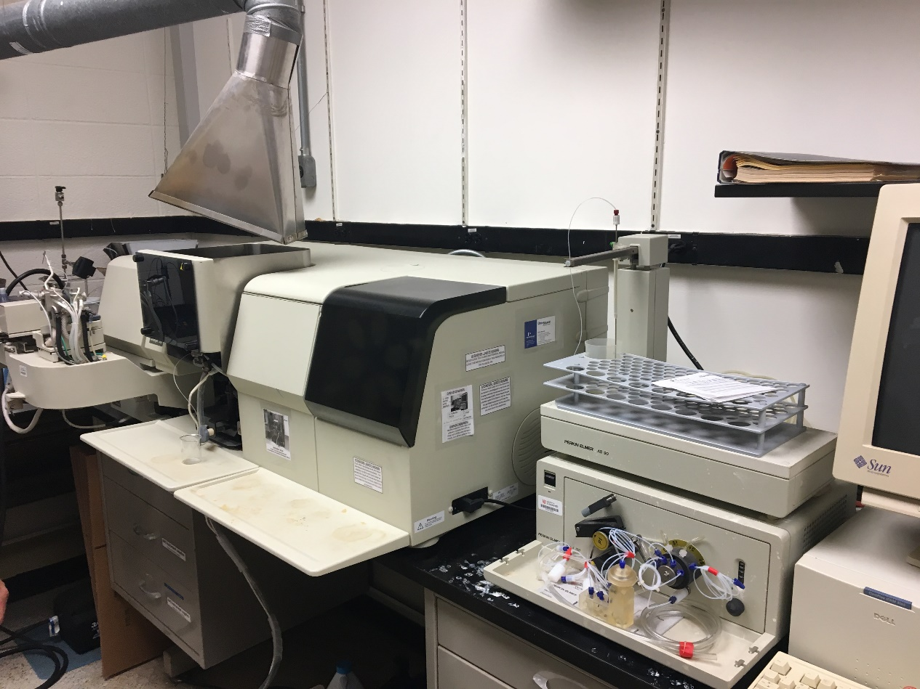

- Atomic Absorption Spectroscopy (AAS) Machine

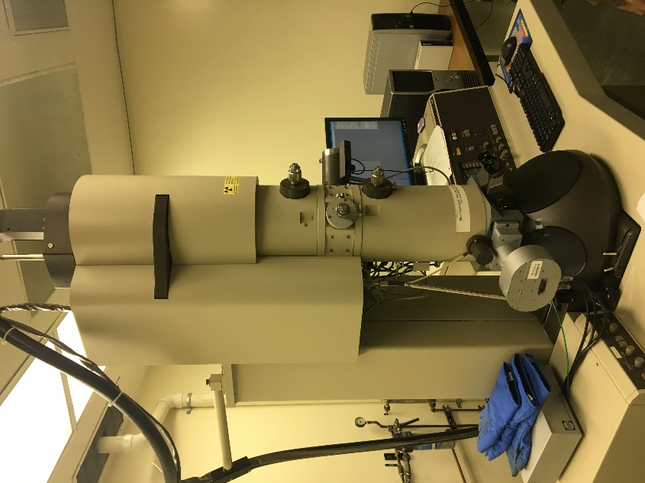

- Transmission Electron Microscope (TEM) Used for Morphology Characterization

- APPENDIX IV: UNIT PLANS

Name: Kimberly Lykens | Contact Info: lykenskimberly@gmail.com | Date: 6/22/17

Unit Number and Title: The Impact of Leaching Metals from Land to Water on Cellular Mechanisms

Grade Level: | 10
Subject Area: | Biological Sciences (Biology)

Total Estimated Duration of Entire Unit: | 11 days

Part 1: Designing the Unit
- Unit Academic Standards (Identify which standards: NGSS, OLS and/or CCSS. Cut and paste from NGSS, OLS and/or CCSS and be sure to include letter and/or number identifiers.):

Ohio’s New Learning Standards (ONLS) Content Elaboration: Cells (p. 295):

- Every cell is covered by a membrane that controls what can enter and leave the cell.
- Within the cell are specialized parts for the transport of materials, energy transformation, protein building, waste disposal, information feedback and movement.
- Complex interactions among the different kinds of molecules in the cell cause distinct cycles of activities, such as growth and division.
- Most cells function within a narrow range of temperature and pH. At very low temperatures, reaction rates are slow. High temperatures and/or extremes of pH can irreversibly change the structure of most protein molecules. Even small changes in pH can alter how molecules interact.
- A living cell is composed of a small number of elements, mainly carbon, hydrogen, nitrogen, oxygen, phosphorous and sulfur.
- Carbon, because of its small size and four available bonding electrons, can join to other carbon atoms in chains and rings to form large and complex molecules.

- Unit Summary
The Big Idea (including global relevance):
- Water Contamination
  - Leaching of metal into drinking water through landfill material and pipe degradation
  - http://www.doh.wa.gov/portals/1/Documents/pubs/331-178.pdf
  - https://www.wpr.org/milwaukees-lead-problem-complex-and-could-cost-billions-fix

The (anticipated) Essential Questions: List 3 or more questions your students are likely to generate on their own. (Highlight in yellow the one selected to define the Challenge):
- How does metal in our water affect human health?
- How can we prevent metals from leaching into water?
- How do the metals in drinking water in Dayton affect our quality of life?

- Unit Context
Justification for Selection of Content– Check all that apply:
☐ Students previously scored poorly on standardized tests, end-of term test or any other test given in the school or district on this content.
☐ Misconceptions regarding this content are prevalent.
√ Content is suited well for teaching via CBL and EDP pedagogies.
√ The selected content follows the pacing guide for when this content is scheduled to be taught during the school year. (Unit 1 covers atomic structure because it is taught in October when I should be conducting my first unit.)
☐ Other reason(s) _____________________________________________________________
_____________________________________________________________________________

The Hook:
Students will be shown a video about the water crisis at Flint Michigan. Students will be given a population of brine shrimp and their job is to determine which water sample they are going to supply to their population of shrimp. Students will make qualitative and quantitative observations about the shrimp and draw conclusions about which water sample is the best to use.

The Challenge and Constraints:

√ Product or √ Process (Check one)
Description of Challenge (Either Product or Process is clearly explained below): | List the Constraints Applied
Students will be provided a small sample of copper powder that they will be asked to contain within a landfill using common household materials. Students will design a way to test the effectiveness of their design by creating of a system that isolates water runoff. | -Must collect at least 250 mL of water  -Limited to supplies provided  -Only 46 minutes to build (plus one redesign)  -Create a process that for the evaluation of the solution  -Multiple steps required in design  -5 g of copper will be provided to each team  -Before second rebuild, students will be notified of an “predicted earthquake” that will shake their system before it “rains”

Teacher’s Anticipated Guiding Questions (that apply to the Challenge and may change with student input.):
- How easily does copper dissolve in water?
- What substances that absorb copper?
- Where is the best place to position the copper container in the landfill?
- How does each provided material interact with water?
- How does copper interact with prokaryotic and eukaryotic cells?
- What is an acceptable amount of copper remaining in the water?

4. EDP: Use the diagram below to help you complete this section.
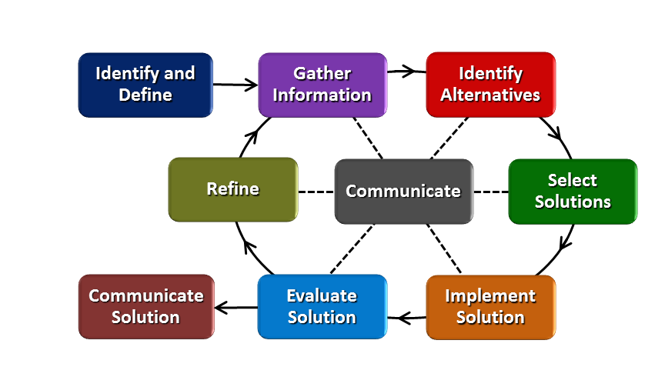
How will students test or implement the solution? What is the evidence that the solution worked? Describe how the iterative process from the EDP applies to your Challenge.
Students will test the solution by creating a system to isolate water run-off. The water run-off will then be analyzed using metal testing strips to assess copper container effectiveness. Evidence that the solution worked will be evaluated by looking at the copper concentration within the water after the design and redesign of the container. Redesign will be a large focus of this activity as students attempt to improve their copper container after the initial test.

How will students present or defend the solution? Describe if any formal training or resource guides will be provided to the students for best practices (e.g., poster, flyer, video, advertisement, etc.) used to present work.
Students will defend their solution by creating a report to the Dayton Landfill describing the effectiveness of their design. This report will also include a section on cellular impact using key vocabulary words from academic content.

What academic content is being taught through this Challenge?
The effects of metals on cell organelles and cell function will be emphasized throughout this challenge. The use of key vocabulary words will be required in student’s final report and the effects of elements that are not conducive for life will be described and connect with results.

Assessment and EDP:
Using the diagram above, identify any places in the EDP where assessments should take place, as it applies to your Challenge. Describe below what kinds of assessment are most appropriate.

What EDP Processes are ideal for conducting an Assessment? (List ones that apply.) | List the type of Assessment (Rubric, Diagram, Checklist, Model, Q/A etc.) Check box to indicate whether it is formative or summative.
Hook brainstorming  Pre-Test  Engineering Design Process Rubric  Final Report | __________Discussion_____________ √ formative ☐ summative  ____________Test_________________ √ formative ☐ summative  __________Rubric_________________ ☐ formative √ summative  _________Report__________________ ☐ formative √ summative
Check below which characteristic(s) of this Challenge will be incorporated in its implementation using EDP. (Check all that apply.)
√ Has clear constraints that limit the solutions
√ Will produce than one possible solution that works
√ Includes the ability to refine or optimize solutions
√ Assesses science or math content
√ Includes Math applications
√ Involves use of graphs
√ Requires analysis of data
√ Includes student led communication of findings

5. ACS (Real world applications; career connections; societal impact):
Place an X on the continuum to indicate where this Challenge belongs in the context of real world applications:
Abstract or Loosely Applies to the Real World | |--------------------------------------|---------------------------X-----------| | Strongly Applies to the Real World

Provide a brief rationale for where you placed the X: Humans need water to live. Leaching metal by degradation and runoff is a large concern for the health of a community. Containing this metal is important to ensure it is not consumed by humans and other wildlife.

What activities in this Unit apply to real world context? All activities to some extent relate to a real-world concept.

Place an X on the continuum to indicate where this Challenge belongs in the context of societal impact:
Shows Little or No Societal Impact | |-------------------------------------|--------------------------------X------| | Strongly Shows Societal Impact

Provide a brief rationale for where you placed the X: Cases of metal leaching into water have affected communities in the United States. Furthermore, the issue of clean water affects communities world-wide.

What activities in this Unit apply to societal impact? Activity 1 & Activity 3

Careers: What careers will you introduce (and how) to the students that are related to the Challenge? (Examples: career research assignment, guest speakers, fieldtrips, Skype with a professional, etc.)
- Chemist
- Water treatment operations
- Chemical Engineer
- Design Engineer
- Environmental Engineer
- Mechanical Engineer
- Materials Engineer
- Systems Engineer

6. Misconceptions:

- All cells are the same size and shape, i.e., there is a generic cell
- Animal cells do not eliminate their own wastes.
- Cells do not need water to function.
- The interior of a cell is solid
- It is not possible for molecules to enter or leave a cell
7. Unit Lessons and Activities: (Provide a tentative timeline with a breakdown for Lessons 1 and 2. Provide the Lesson #’s and Activity #’s for when the Challenge Based Learning (CBL) and Engineering Design Process (EDP) are embedded in the unit.)

Lesson 1 (7 days): Framing the Problem. Students will explore how different water samples affect brine shrimp survival. In doing, so they will use the Big Idea of Water Contamination to determine the Essential Question and Challenge. They will also explore the function of the cell organelles and how water quality impacts their survival
Activity 1 (3 days): Introduction of Big Idea, Essential Questions, Introduce Hook (1 day). Brine Shrimp Hook and water samples (over 3-day period)
Activity 2 (3 days): Elements and Cell Mechanisms, Cell organelles and metals (case study), draw conclusions on brine shrimp experiment
Lesson 2 (5-6 days): How does contamination reach our drinking water and how can we prevent this? Students will visit Dayton Landfill and the Water Treatment plant and conduct challenge on water contamination prevention
Activity 3 (2-3 days): Field trip to Dayton Landfill and Water Treatment Facility followed by discussion
Activity 4 (3 days): Metal Leeching Engineering Challenge/Communicate solution (town hall meeting)
8. Keywords:
-Metal
-Cell membrane
-Cell organelles (nucleus, ribosome, rough ER, smooth ER, nucleolus, cell membrane, Golgi body)
-Leaching
-pH
-Alkalinity
-Proteins
-Nanoparticles
9. Additional Resources:

Dayton Landfill (Educational Resources)

10. Pre-Unit and Post-Unit Assessment Instruments:

Updated pre-unit and post-unit assessments can be found on RET Wiki under “Pre-Test” and “Post-Test.”
11. Poster: RET Wiki | 12. Video (Link here): RET Wiki

If you are a science teacher, check the boxes below that apply:
Next Generation Science Standards (NGSS)
Science and Engineering Practices (Check all that apply) | Crosscutting Concepts (Check all that apply)
√ Asking questions (for science) and defining problems (for engineering) | ☐ Patterns
√ Developing and using models | √ Cause and effect
√ Planning and carrying out investigations | ☐ Scale, proportion, and quantity
√ Analyzing and interpreting data | √ Systems and system models
√ Using mathematics and computational thinking | ☐ Energy and matter: Flows, cycles, and conservation
√ Constructing explanations (for science) and designing solutions (for engineering) | ☐ Structure and function.
√ Engaging in argument from evidence | √ Stability and change.
√ Obtaining, evaluating, and communicating information

If you are a science teacher, check the boxes below that apply:
Ohio’s Learning Standards for Science (OLS)
Expectations for Learning - Cognitive Demands (Check all that apply)
√ Designing Technological/Engineering Solutions Using Science concepts (T)
√ Demonstrating Science Knowledge (D)
√ Interpreting and Communicating Science Concepts (C)
√ Recalling Accurate Science (R)

If you are a math teacher, check the boxes below that apply:
Ohio’s Learning Standards for Math (OLS) or
Common Core State Standards -- Mathematics (CCSS)
Standards for Mathematical Practice (Check all that apply)
√ Make sense of problems and persevere in solving them | √ Use appropriate tools strategically
√ Reason abstractly and quantitatively | ☐ Attend to precision
√ Construct viable arguments and critique the reasoning of others | ☐ Look for and make use of structure
☐ Model with mathematics | √ Look for and express regularity in repeated reasoning

Part 2: Post Implementation- Reflection on the Unit
Results: Evidence of Growth in Student Learning - After the Unit has been taught and the Post-Unit Assessment Instrument has been used to assess student growth in learning, the teacher must analyze the data and determine whether or not student growth in learning occurred. Present all documents used to collect and organize Post- Unit evaluation data such as graphs or charts. Provide a written analysis in sentence or paragraph form which provides the evidence that student growth in learning took place. Please present results and, if applicable, student work (as a hyperlink) used as evidence after the Unit has been taught.

Please include:
- Any documents used to collect and organize post unit evaluation data. (charts, graphs and /or tables etc.)
- An analysis of data used to measure growth in student learning providing evidence that student learning occurred. (Sentence or paragraph form.)
- Other forms of assessment that demonstrate evidence of learning.
- Anecdotal information from student feedback.

Reflection: Reflections: Reflect upon the successes of teaching in this Unit in 5 or more sentences in the form of a narrative. Consider the following questions:
- Why did you select this content for the Unit?
- Was the purpose for selecting the Unit met? If yes, provide student learning related evidence. If not, provide possible reasons.
- Did the students find a solution or solutions that resulted in concrete meaningful action for the Unit’s Challenge? Hyperlink examples of student solutions as evidence.
- What does the data indicate about growth in student learning?
- What would you change if you re-taught this Unit?
- Would you teach this Unit again? Why or why not?

Name: Todd Hamilton | Contact Info: jthamilton24@hotmail.com | Date: 6-23-17

Unit Number and Title: Unit 1: Water Filtration in the Wilderness

Grade Level: | 6
Subject Area: | Science

Total Estimated Duration of Entire Unit: | 18 days

Part 1: Designing the Unit
Unit Academic Standards:
- Rocks, minerals, and soil have common and practical uses (SC.6.ESS.5)
- Minerals have specific quantifiable properties (SC.6.ESS.2)
- Design and construct a scientific investigation (SC.5-8.2)
- Use appropriate mathematics, tools, and techniques to gather data and information (SC.5-8.3)
- Analyze and interpret data (SC.5-8.4)
- Develop descriptions, explanations, models, and predictions. (SC.5-8.5)
- Recognize and internalize alternate solutions (SC.5-8.7)

- Create examples of ways soil, rocks, and minerals can be used.

- Unit Summary
The Big Idea (including global relevance): Water is an essential need for all life. Clean water is not readily available for everyone. How can people clean water using simple, and abundant materials?

The (anticipated) Essential Questions: List 3 or more questions your students are likely to generate on their own. (Highlight in yellow the one selected to define the Challenge):
How can water be purified without chemicals?
How do we determine if water is safe to drink?
What ways can water be cleaned using available and cheap materials?

- Unit Context
Justification for Selection of Content– Check all that apply:
x Students previously scored poorly on standardized tests, end-of term test or any other test given in the school or district on this content.
x Misconceptions regarding this content are prevalent.
x Content is suited well for teaching via CBL and EDP pedagogies.
x The selected content follows the pacing guide for when this content is scheduled to be taught during the school year. (Unit 1 covers atomic structure because it is taught in October when I should be conducting my first unit.)
☐ Other reason(s) _____________________________________________________________
_____________________________________________________________________________

The Hook: (Describe in a few sentences how you will use a “hook” to introduce the Big Idea in a compelling way that draws students into the topic.)
ELA: Students are possibly reading the book Hatchet.
Video: Students shown and discuss video of a person trapped in the wild with limited resources.
Students envision themselves stranded in the wilderness and identify food and water as an essential need.

The Challenge and Constraints:

X☐ Product or ☐ Process (Check one)

Description of Challenge (Either Product or Process is clearly explained below): | List the Constraints Applied
Students will create a water filter using readily available materials found in the wild or on their persons. | Students given a time constraint. (can only survive for 3 days without water)  Given materials found in the wild  - Student led discussion on what could be found in the wild.  Given two water bottles only (personal carry)  - 3 levels minimum 5 max  - Test using conductivity testers, pH strips, colony count.  - pH – 7-8  - Conductivity – 0 – 200  - Colony count – low as possible  - Clarity test (ring on paper)

Teacher’s Anticipated Guiding Questions (that apply to the Challenge and may change with student input.):
- What is physical filtration?
- What is chemical filtration?
- Does carbon physically or chemically filter water?
- What particle size is the best for filtering large contaminants?
- What particle size is the best for filtering small contaminants?
- What are contaminants?
- What kind of contaminants exist in polluted water?

4. EDP: Use the diagram below to help you complete this section.
How will students test or implement the solution? What is the evidence that the solution worked? Describe how the iterative process from the EDP applies to your Challenge.
Students will gather materials they could find outside naturally and will be supplied with materials (2 water bottles, sand, charcoal). Each group will be given “contaminated” water from the same source. Students will test the quality of their water using pH strips and a conductivity tester. After each test groups will refine their filters to yield the best results.
- Basic pH better
- Less conductivity = less metal in water
- Measure biotic factors (iPad application)

How will students present or defend the solution? Describe if any formal training or resource guides will be provided to the students for best practices (e.g., poster, flyer, video, advertisement, etc.) used to present work.
Students will present the work using poster templates and each poster will be printed for a gallery walk and presentation. (gallery walk, ESL and SIOP aligned). Physical posters will be used for the gallery walk and digital poster will be used for the class presentation so students can have access to show any video footage taken.
What academic content is being taught through this Challenge?
Common and practical uses for rocks, minerals, and soil. Characteristics of rocks, minerals, and soil.

Assessment and EDP:
Using the diagram above, identify any places in the EDP where assessments should take place, as it applies to your Challenge. Describe below what kinds of assessment are most appropriate.

What EDP Processes are ideal for conducting an Assessment? (List ones that apply.) | List the type of Assessment (Rubric, Diagram, Checklist, Model, Q/A etc.) Check box to indicate whether it is formative or summative.
__Rubric timeline ___  ___Group collaboration check  _Individual assignment and group poster check  Unit exam EDP and content | ____Rubric___________ ☐ formative X summative  ______Q/A_______ X formative ☐ summative  ______Checklist__________ X formative ☐ summative  ____Poster and Exam ____________ ☐ formative X summative
Check below which characteristic(s) of this Challenge will be incorporated in its implementation using EDP. (Check all that apply.)
X Has clear constraints that limit the solutions
X Will produce more than one possible solution that works
X Includes the ability to refine or optimize solutions
X Assesses science or math content
X Includes Math applications
X Involves use of graphs
X Requires analysis of data
X Includes student led communication of findings

5. ACS (Real world applications; career connections; societal impact):
Place an X on the continuum to indicate where this Challenge belongs in the context of real world applications:
Abstract or Loosely Applies to the Real World | |--------------------------------------|--------------------------X------------| | Strongly Applies to the Real World

Provide a brief rationale for where you placed the X: Water filtration is an essential component for established cities. Many communities are left with challenges that limit resources to filter and clean water. Even in developed countries like the U.S. people are often faced with problems of contaminated water.
What activities in this Unit apply to real world context? Activities 1 and 5 apply to a water source crisis in which drinkable water is hard to find or obtain. Flint’s water crisis and water source issues in developing countries are real world applications.

Place an X on the continuum to indicate where this Challenge belongs in the context of societal impact:
Shows Little or No Societal Impact | |-------------------------------------|-----------------X-----------------------| | Strongly Shows Societal Impact

Provide a brief rationale for where you placed the X: Basic water purification skills are important for people to know and understand in order to supply families and communities with the basic need for water.
What activities in this Unit apply to societal impact? Activities 1-5 address knowledge needed to create simple filters that are effective in filtering contaminants in water to create drinkable water from a contaminated source.

Careers: What careers will you introduce (and how) to the students that are related to the Challenge? (Examples: career research assignment, guest speakers, fieldtrips, Skype with a professional, etc.)
Environmental engineer – Water quality video, guest speaker*
Soil conservationist – Field Trip (Green Acres)

6. Misconceptions:

- Water is safe to drink if it is clear.
- Soil or sand can make water dirty and unsafe to drink.

7. Unit Lessons and Activities: (Provide a tentative timeline with a breakdown for Lessons 1 and 2. Provide the Lesson #’s and Activity #’s for when the Challenge Based Learning (CBL) and Engineering Design Process (EDP) are embedded in the unit.)

Unit 1: The Composition, Properties and Applications of Rocks, Minerals, and Soil - Design and Test a Water Filtration System from Materials Found in Nature to Ensure Hydration if Stranded in the Wild.
Lesson 1: Exploring Soil Profiles and the Composition/Properties of Soil Horizons. ( 7 days)
Lesson 1 will focus on giving students an understanding of how soil forms layers (horizons) based on the density of particles within the soil. Students will gain an understanding of how water infiltrates through a soil profile to become a part of larger underground river systems and aquifers. Students will explore the composition and properties of each horizon and study how these horizons develop given different environmental conditions.
Activity 1: Introduction to Big Idea, Generating the Essential Questions (Where did Jack and Jill get their water? Why?) Creating a Soil Profile (Soil sample shake in mason jar). (2 Days)
Activity 2: Exploring Soil Horizons Composition and Properties, The Infiltration of Water Through a Soil Profile and Underground Water Systems. (5 Days)
Lesson 2: Properties of Sand, Silt, Clay and Loam. Soil Triangles, and Water Infiltration/Absorption. (8 Days)
Lesson 2 will focus on giving students an understanding of the singular components of soil. Students will learn how to use a soil triangle to identify samples of soil and test these samples on how effective they are in allowing water infiltration or water absorption. Students will explore particle size and create theories on what could and could not pass through these particles. Students will then be challenged to design an effective water filtration system using only what they can find in nature.
Activity 3: Introduction to a Soil Triangle and the Properties of Sand, Silt, Clay, and Loam. (particle size exploration & sample identification) (3 Days)
Activity 4: Effectiveness of Infiltration and Absorption Using Soil Samples (2 Days)
Activity 5: Design and Test an Effective Water Filtration System Using Only Materials Found in Nature (3 Days)
CBL – Activities 1 and 5
EDP – Activity 5
8. Keywords: rocks, minerals, soil, soil horizon, soil profile, sand, silt, clay, loam, particle, contaminants, biotic, abiotic, filter, leaching, infiltration, absorption,

9. Additional Resources: https://www.jpl.nasa.gov/edu/teach/activity/water-filtration-challenge/

10. Pre-Unit and Post-Unit Assessment Instruments:

11. Poster | 12. Video (Link here.)

If you are a science teacher, check the boxes below that apply:
Next Generation Science Standards (NGSS)
lScience and Engineering Practices (Check all that apply) | Crosscutting Concepts (Check all that apply)
X Asking questions (for science) and defining problems (for engineering) | X Patterns
X Developing and using models | X Cause and effect
X Planning and carrying out investigations | X Scale, proportion, and quantity
X Analyzing and interpreting data | X Systems and system models
X Using mathematics and computational thinking | X Energy and matter: Flows, cycles, and conservation
X Constructing explanations (for science) and designing solutions (for engineering) | X Structure and function.
X Engaging in argument from evidence | X Stability and change.
X Obtaining, evaluating, and communicating information

If you are a science teacher, check the boxes below that apply:
Ohio’s Learning Standards for Science (OLS)
Expectations for Learning - Cognitive Demands (Check all that apply)
X Designing Technological/Engineering Solutions Using Science concepts (T)
X Demonstrating Science Knowledge (D)
X Interpreting and Communicating Science Concepts (C)
X Recalling Accurate Science (R)

If you are a math teacher, check the boxes below that apply:
Ohio’s Learning Standards for Math (OLS) or
Common Core State Standards -- Mathematics (CCSS)
Standards for Mathematical Practice (Check all that apply)
X Make sense of problems and persevere in solving them | X Use appropriate tools strategically
X Reason abstractly and quantitatively | X Attend to precision
X Construct viable arguments and critique the reasoning of others | X Look for and make use of structure
X Model with mathematics | XLook for and express regularity in repeated reasoning

Part 2: Post Implementation- Reflection on the Unit
Results: Evidence of Growth in Student Learning - After the Unit has been taught and the Post-Unit Assessment Instrument has been used to assess student growth in learning, the teacher must analyze the data and determine whether or not student growth in learning occurred. Present all documents used to collect and organize Post- Unit evaluation data such as graphs or charts. Provide a written analysis in sentence or paragraph form which provides the evidence that student growth in learning took place. Please present results and, if applicable, student work (as a hyperlink) used as evidence after the Unit has been taught.

Please include:
- Any documents used to collect and organize post unit evaluation data. (charts, graphs and /or tables etc.)
- An analysis of data used to measure growth in student learning providing evidence that student learning occurred. (Sentence or paragraph form.)
- Other forms of assessment that demonstrate evidence of learning.
- Anecdotal information from student feedback.

Reflection: Reflections: Reflect upon the successes of teaching in this Unit in 5 or more sentences in the form of a narrative. Consider the following questions:
- Why did you select this content for the Unit?
- Was the purpose for selecting the Unit met? If yes, provide student learning related evidence. If not, provide possible reasons.
- Did the students find a solution or solutions that resulted in concrete meaningful action for the Unit’s Challenge? Hyperlink examples of student solutions as evidence.
- What does the data indicate about growth in student learning?
- What would you change if you re-taught this Unit?
- Would you teach this Unit again? Why or why not?

